­­­­­­



**School of Science and Technology**

**BIS3214**

**Data Warehousing and Business Intelligence**

**Coursework 1**

**Autumn/Winter term**

**2014/2015**

|  |
| --- |
| **Date:** 30rd January 2015 |
| **Supervisor:** Dr. Syed Murad |
| **Campus:** Hendon |
| **Group Members:** |

|  |  |  |  |
| --- | --- | --- | --- |
| Cristiano Cardoso Maia  M00322036 | Jade Van Nelson  M00405270 | Kateryna Vyshnyak  M00330646 | Veeraj Bhura  M0041555 |

Table of Contents

1. Introduction 3

1.1 Middlesex University 3

1.2 Types of Management 3

1.3 Objectives, Values and Mission 4

1.4 Marketing Department 4

2. Analysis of Operational Systems and Data Sources 5

2.1 Entity Relationship Diagram (ERD) description 5

2.2 Data Warehouse – Advantages and Disadvantages 9

2.3 Table of Comparison 9

3. Data Mart Design 11

3.1 Subject areas identification 11

3.2 Star Schema Diagrams 11

3.3 Granularity 12

3.4 Snowflake Schema 13

4. ETL process 13

4.1 Data Extraction, Transformation and Loading (ETL) 13

4.2 Extraction Methods in DWs 14

5. OLAP 15

5.1 Different OLAP Techniques 15

5.1.1 MOLAP 15

5.1.2 ROLAP 16

5.1.3 HOLAP 16

5.2 Definitions 16

5.2.1 Slicing 16

5.2.2 Dicing 17

5.2.3 Drill Down/Up 17

5.3 Implementation 18

5.4 SQL Queries 22

7. Conclusion 28

8. References 30

9. Appendices 31

Github Repository: 31

Agendas 32

Minutes 34

Assessments Forms 41

# 1. Introduction

## Middlesex University

A University in England with roots back to 1878 who has since build up a reputation in London and international as a providing a high level of higher education from its wealth of experience and strategic operational capabilities. Through strengthening our efficiency by employing highly qualified academics, attracting the best ambitious students and strengthening our research reputation we can capitalise internationally on becoming an excellent international tertiary education establishment.

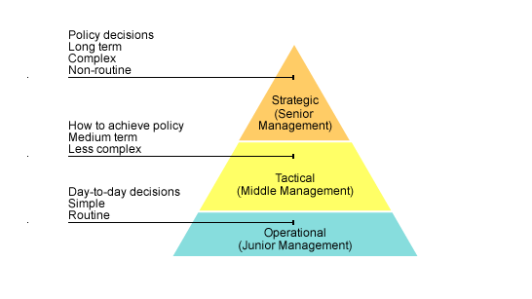

Figure 1 – Business Management Model (BBC)

## Types of Management

The Government Business Reference Model shown above illustrates the three levels of control that the university runs with. All major decisions that has to be made as far as what the university needs to achieve long-term and how they need to achieve it are made at the Strategic level (Senior Management). On the same level you will find job titles such as dean, chancellor, vice chancellor and many other high-ranking job titles as they have the power and knowledge that it takes to make complex decisions.

All the decisions made by the Senior Management team will be passed to the Tactical level of management (Middle Management). This action is important to make sure the whole University is aligned with the same objectives and aims. Middle management staff (such as the head of department) will be responsible to develop a plan to implement the direction given to the managers in the operational bracket.

Finally, the Operational level (junior management) is responsible to implement the overall goal. This level is where professors, librarians and other university staff that deals directly with the students, will take the instructions from the above two management teams. With the training and experience provided by Middlesex they will be able to implement the strategies to turn the strategic plans in reality. They will also be responsible do report their progress directly to the Middle management team.

## Objectives, Values and Mission

Our Objectives are to attract students that are determined to succeed and support these students with the correct support and insure student satisfaction by developing policies to maximise their performance. We strive to enhance graduate level employability in an effort to improve our university rankings. We have strategies and policy to organise our schools to enhance excellence.

“Our vision is to become a leading University of choice, recognised internationally for excellence in all that we do.”

## Marketing Department

Middlesex University Marketing department is based at the Middlesex University London campus. The department specialises and focuses on each of the five schools across three different campuses universally. The department receive funding for our advertising projects from the relevant departments. The marketing department managers will detail projects and allocate tasks accordingly. This will be inline with equity and diversity strategy, University regulations and decision-making and discussions held at middle management meetings. There after the relevant departments would handle the assignments and would also manage the suppliers and supplies to the project (Middlesex University).

Middlesex University will not consider all staff to be participating in one project each staff member will be assigned to a specific project and task in that project. The projects are based on the development of current marketing tools available. E-commerce and online marketing trends are generating popularity and there for more funding is spend on online marketing, thus to insure that the marketing department achieves its aims and goals. These projects are the same projects from the departments of each school and the content is made available in the means of online marketing and various other outlets depending on the projects.

The list of local and international suppliers is available locally, nationally or internationally. The supplier catalogues and the supplier contracts are saved in the contracts database. A specific enquiry regarding contracts and agreements with the relevant suppliers will be approved by the marketing department and will be inline with the university's framework, mission or scope, the suppliers can provide anything that will physically assist the projects needs. Permanent MDX staff will not be considered for these projects as they are the “clients”. Overall the objectives of the marketing department is to attract students that work hard and willing to go the extra mile to reach success in their studies.

The marketing department is important for the whole University as it influences the direct correlation between the success rate and the rates of new students attending the University. The marketing department is one of the most important business departments of most any company but especially so in this case as the University renders a services namely education.

# 2. Analysis of Operational Systems and Data Sources

## 2.1 Entity Relationship Diagram (ERD) description

In introduction to the following report we will be covering various topics, thus starting with the link between the advantages and disadvantages of operational databases to data warehouses. We will also cover the how the marketing department has developed its own operational database in correlations with an ERD.

The different projects allow the University to meet its objectives by planning events and managing these events. These projects have cost and they are directly related to the project thus a budget is set by each department as to how much would be spend.

The values are met by taking into consideration the long-term effects these projects will have on staff members, attendees and the different attractions held at these events that could generate positive publicity in line with the values of the university.

The mission is to attract the highest amount of high calibre students and by having different projects like open days, digital and social media events, career events and more traditional events at university like research projects the marketing fulfil its mission.

The ERD that we have displayed below shows all the different entities and their attributes. This will allow us to show relationships across all the entities and compose a data mart that will display relevant information so that Middlesex University at the strategic level can make informed choices in how the budget should be used. The ERD will also show the university a cornucopia of other information like what suppliers are used at certain events and what the turnout of the event was. The ERD is vital to the success and longevity of the database and the data mart as if any relationships are missing or any entities have been missed this could result in the error in running queries and retrieving accurate results.

At every event each member of staff plays a crucial role like events management, relations officer from marketing would be there to insure that everything goes according to plan. The member of staff is picked for each event by a few criteria; these criteria are their expertise as to the role that they are required to fill.

After events and during the course of the year all staff members that are part of the Middlesex University marketing department or are part of an event that the marketing department has held need to be paid for their work.

To keep a track of all the task and how they were accomplished in the past will help us to understand perhaps how to overcome current difficulties but also will be beneficial to justify our expenditure. How we have managed the task indirectly relates to our budget and therefore we could justify requesting more budgets for projects as we have specific amount of task that was not completed with other projects and therefore we perhaps under performed as a marketing department

Different venues can be held in different countries thus the university fulfils its mission of attracting international attention as well as focusing on the international students who represent a large amount of the university target audience.

Each project would occur at a venue and to organise the events would have different sessions booked in by booking therefore being able to ascertain the correct amount of space allocated. This takes care of the logistical matters like seating plan, amounts expected to be catered for and falls under general event management.

1. **Role – Staff**
   1. *Cardinality*: 0..* – 1..1
      1. Each member of staff in the department has a specific role to play.
      2. Each Role has a name and a staff member is added to that Role.
2. **Staff – Tasks – Projects**
   1. *Cardinality*: 1..1 – 0..* and 0..* – 1..1
      1. A project can have 0 (in case the tasks hasn't be assigned yet) or many tasks but a specific task can only be related to one project. An extra table called Task History is responsible to keep track of all the tasks from any project even if it has been archived. Along with the keeping track of the staff that was part of the task.
3. **Venue – Booking**
   1. *Cardinality*: 1..1 – 1..1
      1. The marketing department has a list addresses of venues names and locations. These venues are booked by bookings and each session is part of an event.
4. **Booking – Sessions**
   1. *Cardinality*: 1..1 – 1..1
      1. The sessions is booked by the bookings.
      2. A booking has only one session.
5. **Attendee list – Sessions**
   1. *Cardinality*: 0..* – 1..1
      1. For every session there is an attendee list so that the number of attendees can be recorded for after analysis.
      2. One attendee list belongs to only one session.
6. **Events – Projects**
   1. *Cardinality*: 0..* – 1..1
      1. An event can have 0 (if the event is online) or many to many projects. Events are optional for each Project but one event can only be related to one Project at time.
7. **Supplier Rep – Supplier Company**
   1. *Cardinality*: 1..1 – 0..*
      1. Not all the supplier companies have a supplier representative, but all the supplier representatives belongs to one, and only one supplier company.
8. **Supplier Rep – Project**
   1. *Cardinality*: 0..* – 1..1
      1. Not all projects will need to have external suppliers while other suppliers will have many of them. A supplier representative will be supplying to only one project at time.
9. **BudgetCodes – Department**
   1. *Cardinality*: 1..1 – 1..*
      1. Each department will create different budget codes as each one of them will be assigned to a specific project. One budget code is directly linked with one specific department.
10. **BudgetCodes- Projects**
    1. *Cardinality*: 1..1 – 1..1
       1. All the projects will have a budget code but each project can only receive budget from one department.
11. **Expense sheets - Budget Codes**
    1. *Cardinality*: 1..* – 1..1
       1. The project budget is controlled by the analysing the Expense Sheets. Each Budget Code will have many Expense Sheets associated with it but one sheet can only be associated with one budget code.

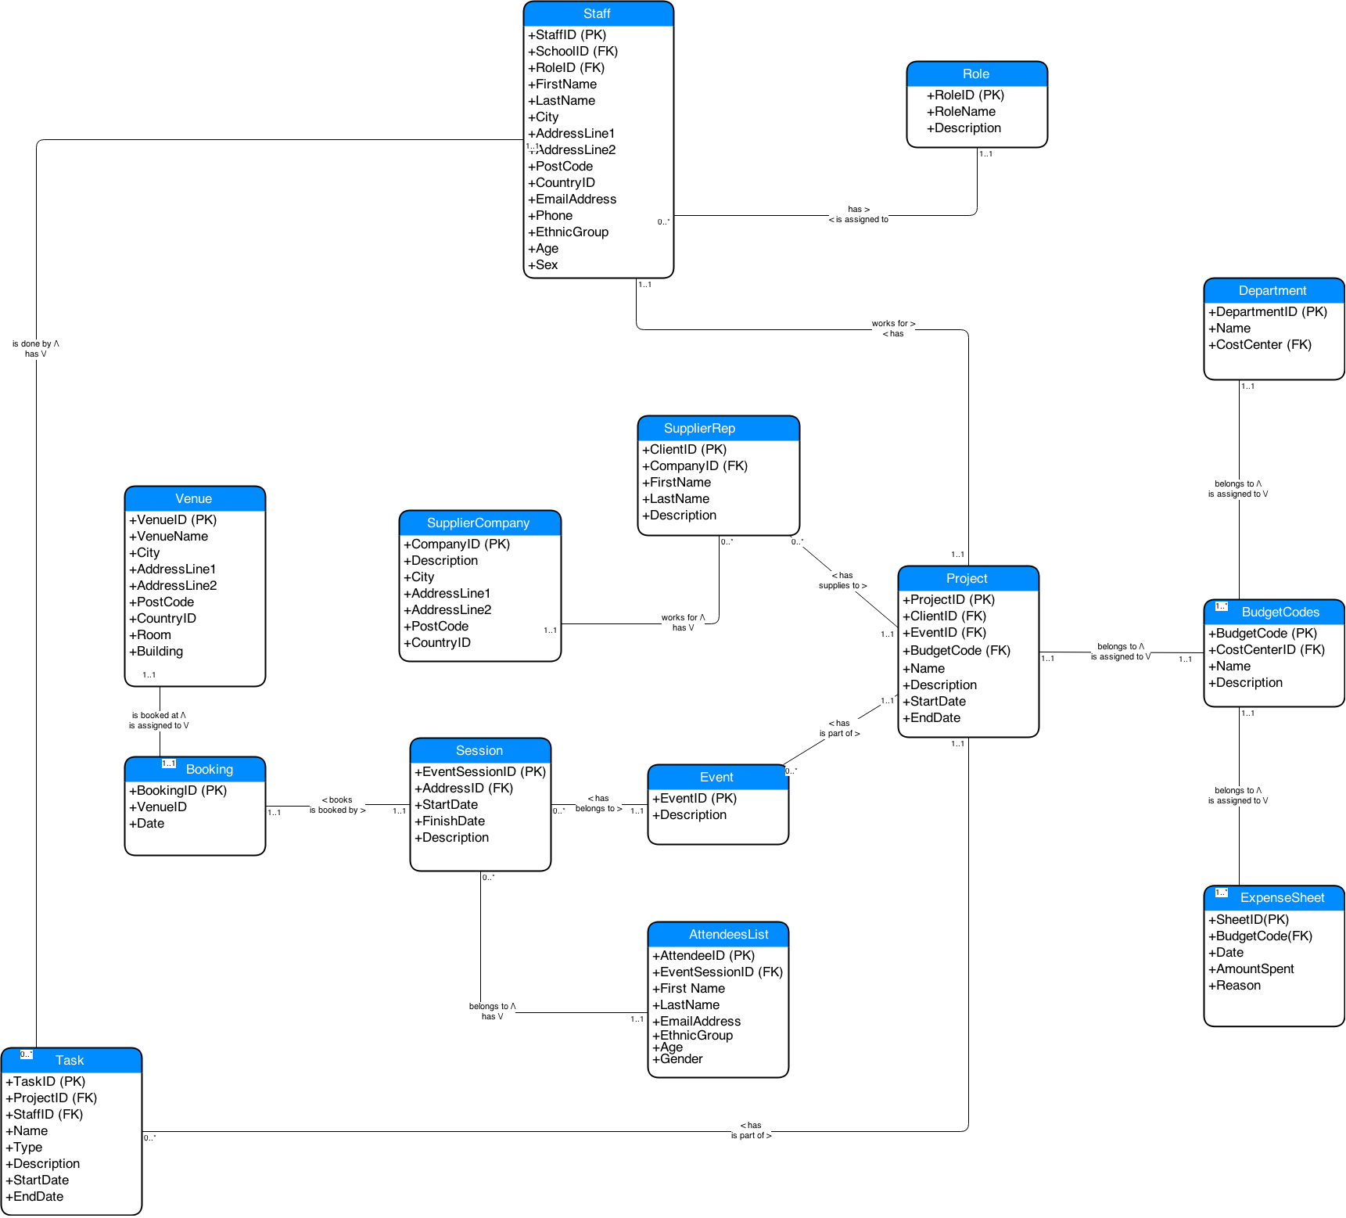

Figure - Entity Relationship Diagram

## 2.2 Data Warehouse – Advantages and Disadvantages

Database is structured data gathering and data processing model. There are two main forms of databases, operational databases and analytical databases. This chapter will define each one of them and state their advantages and disadvantages.

The Operational Databases are company’s core transaction processing (OLTP) scheme that collect, modify and sustain data on a daily basis. The same type of database is also responsible to process and manage dynamic flow of real-time data. It allows access to the archived data and permits data modification of this data such as deletion, adding or updating.

Disadvantages of Operational Databases (OD) in their design as it cover data entry purposes only. Online quires and analytics must be simple, as operational database has “relational” not “dimensional”. Therefore, OD is unable to quickly consolidate, cleanse and integrate data from multiple, disparate databases that run on different technical platforms in different geographical locations. Thus result in poor business intelligence results in poor strategic and tactical decision making

Operational database is designed to process and manage dynamic flow of real-time data. It allows access to the archived data and permits data modification of this data such as deletion, adding or updating. The significant difference between operational and warehouse systems are that operational system designed to assist with transaction process whereas data warehousing oriented for online analytical process (OLAP) (Exforsys). Therefore usage of data is optimized for different purposes, see Table 1 below.

## 2.3 Table of Comparison

|  |  |
| --- | --- |
| **Operational Database** | **Data Warehouse** |
| Provides process-oriented or process-driven analysis only around defined processes of the business and its tasks. | Provides subject-oriented analysis with main focus on the business area where company requires strategic decisions. The collected information is concise about particular issue and collected from more than one operational source. The data analysis produce information about short-range strategies its assessment and evaluations. |
| Dealing with current data and this data updated on the regular basis. | Dealing with historical data and this data rarely changed. Data warehouse stores information as non-volatile and read only format. This data is loaded on the regular basis and growing constantly. |
| System optimized for fast data uploading but small content at the time. | System optimized for fast data retrieval and large content at the time. |
| Data is specific to application performance; therefore it is non-integrated or partially integrated causing data redundancy. | Controlling data redundancy problems within DBSM integration layer. |
| Doesn’t require expert level of computing skills to navigate system. | Requires advance computing knowledge to navigate system. |
| Supporting high-volume transaction performance with minimum rear reporting. | Supporting high-volume analytical transactions with maximum reporting that promptly used for making strategic decisions. |

Table Operational system VS data warehouse (Rensselaer).

Data Warehouse is computerised system for storing information. This information helps organisation to analyse historical patterns and make important business decisions. The advantage of having large repository of information that it helps to solve number of problems, increase company profitability while and reduce cost to access this historical data within external sources. Furthermore, the data is consistent, relevant, structured and combined from various locations into one centralised location. This data centralisation helps to find multiple solutions than where data analysed separately. Data Warehouse allows storing already retrieved data within operational level that improves turnaround time of data reporting and analysis (Power).

The advantage of having data warehouse in marketing is that the data is static and provides a "single version" of the truth about enterprise activities. To understand better its customers – students, future prospects on the marketplace and event’s opportunities to attract more students – customers, researchers and funds.

However there are a number of disadvantages that need to be addressed. Firstly, data warehouse is very expensive to maintain, as data itself must be normalised, loaded and extracted. Moreover, company have to train their users, otherwise it could lead to the security problems while conducting any queries via online access. Secondly, there is always a chance that new transaction system may not be compatible with the currently used systems. There are also a numerous ways of storing information in the data warehouse and applying one set of rules might not be beneficial if in the future company decides to change the way it conducts business (Exforsys). A Data Warehouse is also very slow.

# 3. Data Mart Design

## 3.1 Subject areas identification

### 3.1.1 Event Analysis

One of the objectives and keeping in line with the University strategy is to increase the amount of students who would actually attend the University. This can be directly measured by to the success rate of the events held at University. Keeping track of the amount of events and the most successful event types at each location over time will allow us valuable intelligence has to how to plan for future marketing events.

### 3.1.2 Expenditures

The projects themselves will be held at a location over a specific time period. This fact table allows user to compare the financial side of different projects and filter it by time and/or location. The user can also compare the total project budget per school or type of events for examples.

This fact table allows the user to compare the financial side of different projects and filter it by time and/or location.

## 3.2 Star Schema Diagrams

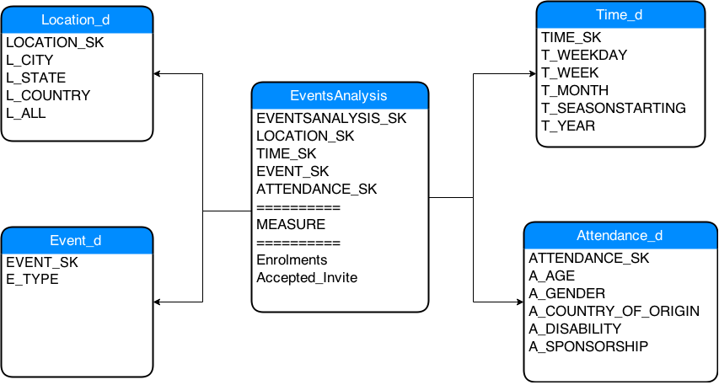

Figure - Event Analysis Start Schema

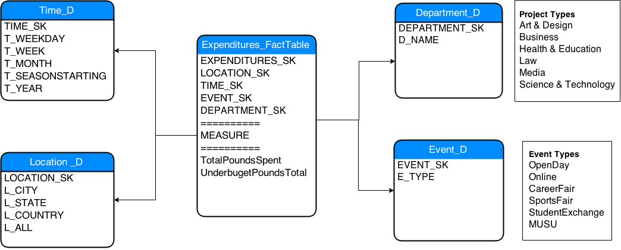

Figure - Expenditures Start Schema

## 3.3 Granularity

The information stored and composed in a fact table can distinguish the granularity of the table by the extend of the amount of subdivide information added. The less there are the fewer pieces of distinct information means that there will be less granularity. An example would be the Location_D with its 4 fields: City, State, Country and All.

The granularity is important as it allows more than one type of queries that can be queried. If there are a few granularities then it means that there are less fields of information and if the granularity is high then it means that there are a lot of fields and thus we can query in a more intelligent way. Not always it’s necessary to have all the possible combinations of granularity for example on the Time dimension we are not interested in knowing how much money was spend per hour.

A fact table is the summary of the information gathered from all the other dimensions. The fact table can be filtered by location, time and any other relevant attributes from any dimension table.

The numeric values in fact tables are divided into three main categories:

* Additive: These measures can be summed across any dimension associated with that fact table.
* Semi Additive: These can sum over some dimensions but not all and the budget balance amounts are semi addictive as there are not over time.
* Non – Additive: Cannot be aggregated using sum but can use functions as minimum, maximum and average (Corr & Stagnitto, 2011).

## 3.4 Snowflake Schema

A refinement of star schema where some dimensional hierarchy is normalized into a set of smaller dimension tables, forming a shape similar to snowflake.

There are differences between a snowflake scheme and a start schema. A star schema is good for a data mart where as a snowflake schema is good for a data warehouse. A star schema only consists out of single dimension tables whereas snowflake schema would consist of more dimensions as shown below. A Top down approach is taken with start schema where as a bottom up is taken with snowflake schema (By Ralph Kimball, 2013).

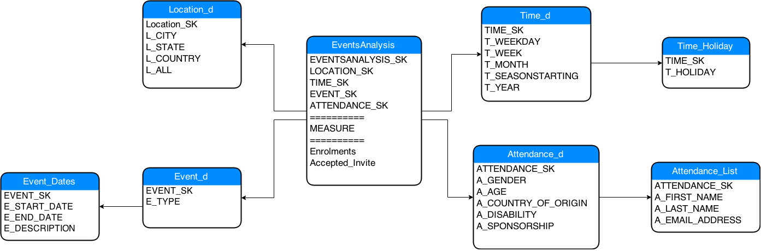

# 4. ETL process

## 4.1 Data Extraction, Transformation and Loading (ETL)

According to G. Goos et all., (2003) Data Warehouse (DWs) purpose is to process and facilitate decision making processes. Therefore, the Extraction-Transformation-Loading (ELT) functionality is important to facilitate any query within complex computer systems. ETL processes are liable to extract data from operational data sources, transformation of these data, including normalization, and loading clean data back to DWs. That process is crucial component of DWs data flow as incorrect or misinterpreted data will lead to the inaccurate business decision, therefore data quality must be observed at its early stage of loading. The design of ETL processes structured in 6 tasks:

1. **SOURCE EXTRACTION**

Includes extraction of data from many operational systems. To obtain desired dataset more data might be extracted, the size of it depends on actual system and business requirements.

1. **TRANSFORM THE SOURCES**

Includes processes of filtering to required dataset. The filtering tasks will include calculating values originated values, converting between different data formats and codes, sequence numbers automatic generation, elimination of duplicates and eliminating unwanted information. The most complex and time-consuming transformations are Multistage Data Transformation and Pipelined Data Transformation.

1. **JOIN THE SOURCES**

Includes merging different operational sources for unique data loading.

1. **SELECT TARGET TO LOAD**

Includes selection process of the target that must be loaded into the system.

1. **MAP SOURCE ATTRIBUTES TO TARGET ATTRIBUTES**

Includes mapping process of extracted attributes to the corresponding target elements.

1. **DATA LOAD**

Incudes upload of transformed data into DWs.

The vital stage of ELT process is data cleaning with identifying and eliminating errors and data discrepancies in order to increase data quality. According to Goos G, Hartmanis (2003) “Data quality problems are very significant: it has been estimated that poor quality customer data cost U.S. businesses $611 billion a year in postage, printing, and staff overhead.” Therefore the conceptual modeling of ETL processes is beneficial for running and maintaining Data Warehouse.

## 4.2 Extraction Methods in DWs

The extraction method depends on the source system, warehouse environment and business needs, and this influences the data source, the transportation process and the time need it to update Warehouse. Generally speaking the data for extraction might be badly documented and therefore extraction will be acquired several times. The source system cannot be modified to accommodate needs of the data warehouse extraction processes; therefore two types of extraction identified such as Logical and Physical.

The **Logical extraction** method used when there is no possibility to add additional logic to the source systems to improve its performance. There are two types of logical extraction:

* **Full Extraction** exports currently available data on the source system. An example for a full extraction may be an export file of a distinct table or a remote SQL statement scanning the complete source table.
* **Incremental Extraction** exports data that has been changed since specific time event. This information can be recorded by source system reflecting to the date stamps or by change- capture mechanism. Instead of exporting entire tables it captures and exports only areas with latest implementation. This method is particularly useful on big chunks of data.

The **Physical Extraction** method depends what logical extraction method was applied, also on the source system effectiveness and limitations. There are two mechanisms of physical extraction online from the source system or from offline structure.

* **Online extraction** exports data from the source system or from the intermediate system that stores data in log format. The extracted information must be determined whether it is extracted from the original entity or prepared entity.
* **Offline extraction** exports data outside of original data source system. This data available in redo logs, archive logs or transportable table-spaces or was created by previous extraction routine. There are several structures to be aware of:
  + **Flat files** (contains generic format of outlined data, requires additional information for further managing),
  + **Dump** files (Oracle distinct files, outlined data might be not present),
  + **Redo and archive logs** (information stored in additional dump file),
  + **Transportable table-spaces** (used to extract and transport large volumes of data between Oracle databases), (Oracle, 2014).

# 5. OLAP

To analyse Middlesex University’s data mart and the information held within the team has chosen to use Online Analytical Processing (OLAP) technology, this technology allows the university to run queries on the data that would normally take far too long to run manually and be too complex. In addition, the university will also be able to gather information that can be utilized in strategic planning, answering various questions and business problems.

OLAP is also referred as “Data Cube” and allows access to older and current data so that users can execute analytical queries. OLAP cubes normally have 3 visual dimensions, but in theory there isn’t any official limit of dimensions. OLAP’s approach main focus is acquiring, consolidating, and condense the enormous amount of data records that are produces. There are many different types of operations that will be covered in the next few paragraphs that allow the technology to analyse the data, and then organizes the data in user-friendly graphical representations so that it can be easily understood.

## 5.1 Different OLAP Techniques

## 5.1.1 MOLAP

MOLAP or multi-dimensional OLAP is one of two techniques that are most widely used to analyse multidimensional cubes that house data. In comparison to the other technique used MOLAP differs slightly in the sense that in some application not all MOLAP requires pre-computed and allocation of information into the cube that it is managing. With this being said this leads to one of the advantages of MOLAP, which is that it allows the data to be queried faster because the data is already optimized. MOLAP however is a very expensive technology; this is one of its disadvantages.

## 5.1.2 ROLAP

ROLAP or Relational OLAP is significantly different from MOLAP. In the sense that where MOLAP requires pre-computed and stored information to analyse the data cubes, ROLAP does not. ROLAP is generally used for large data sets as its performance it much slower than MOLAP. ROLAP access data in relational databases and then uses SQL queries to calculate, this is also only performed when the user requires the information.

## 5.1.3 HOLAP

Hybrid OLAP (HOLAP) is a combination of the above three OLAP, ROLAP, and MOLAP. HOLAP stores the relational database in the ROLAP format, whilst keeping the aggregated data in a multidimensional table in the MOLAP format. This then allows a faster processing time for queries and on the other hand a fast response time for querying detailed data in ROLAP at a fast response rate. The advantage of HOLAP is smaller cubes for faster response times.

## 5.2 Definitions

## 5.2.1 Slicing

Slicing allows a user to take a multidimensional view and turn it into a 2d view that can show data along one slice or side of a layer. This allows the users to go through specific cubes of data along that slice for detailed analysis (Verma, 2009).

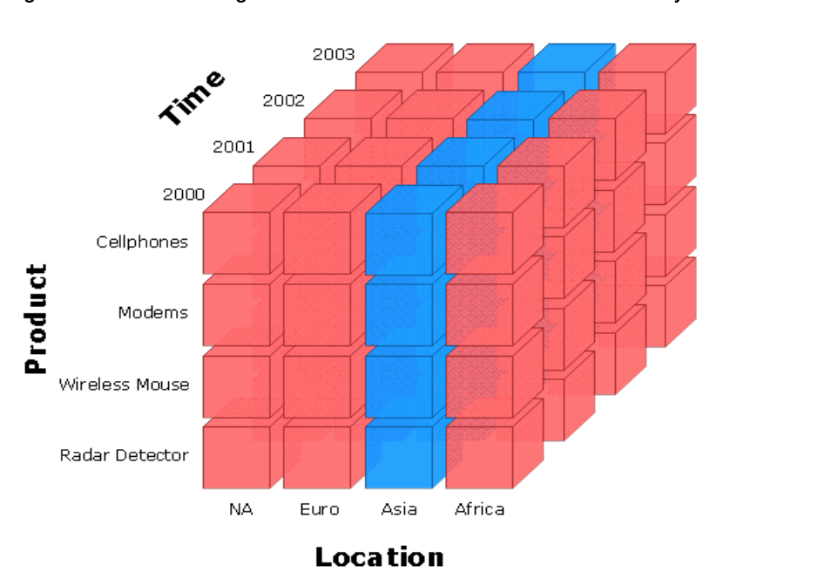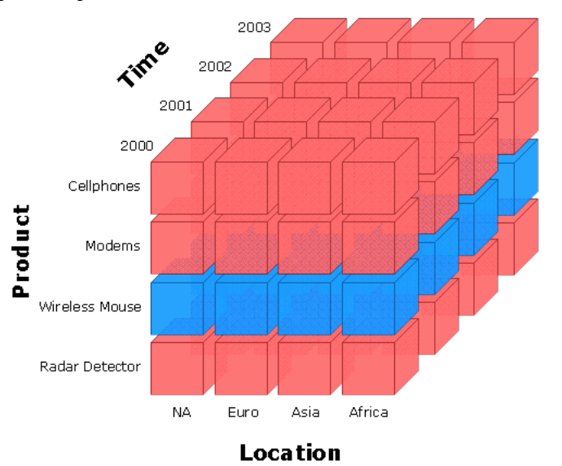

Figure - This picture shows a vertical Slice

Figure - This picture shows a horizontal slice

## 5.2.2 Dicing

Dicing is very similar to slicing where is allows the user to examine a row of data, but dicing differs in the sense where slicing allows you to look down a slice of data. Dicing allows the user to look at much more detail and look at every cube or cubes in any row or column (Verma, 2009).

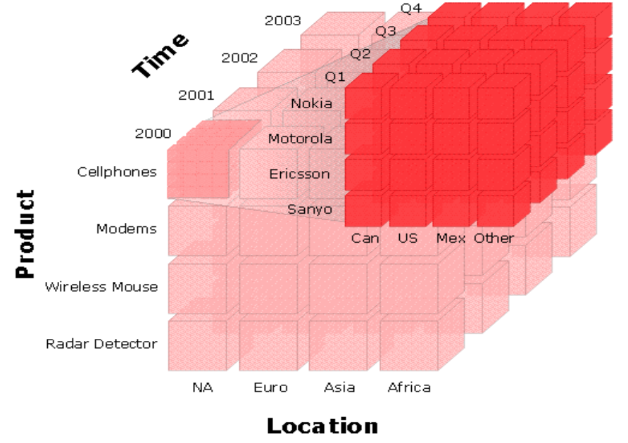

Figure - The above diagram shows dicing

## 5.2.3 Drill Down/Up

To drill up/down is an analytic technique where the user will drill up to find data that is most summarized and drill down for data most detailed (Verma, 2009).

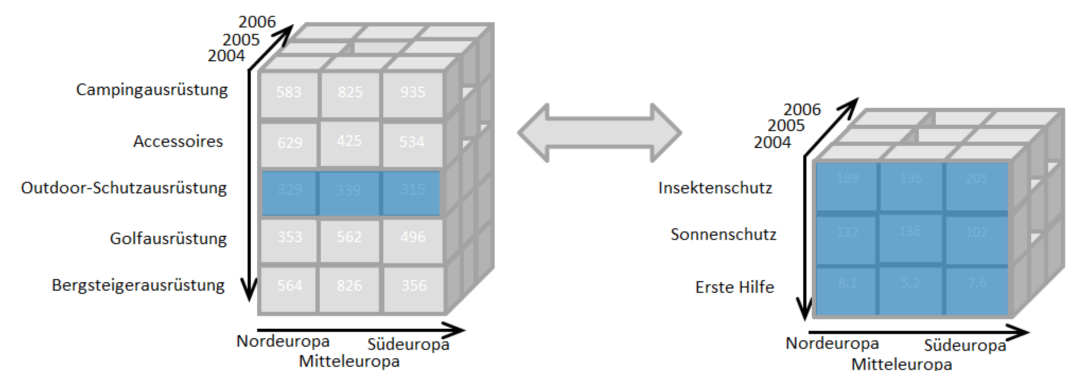

Figure - The above diagram show-drilling up/down respectively

## 5.3 Implementation

### Create Department Dimension, respective sequential trigger and insert value into it

CREATE TABLE DEPARTMENT_D

("DEPARTMENT_SK" NUMBER(*,0) NOT NULL ENABLE,

"D_NAME" VARCHAR2(20 BYTE),

CONSTRAINT "PROJECT_D_PK" PRIMARY KEY ("DEPARTMENT_SK")

);

CREATE OR REPLACE TRIGGER DEPARTMENT_D_TRG

BEFORE INSERT ON DEPARTMENT_D

FOR EACH ROW

BEGIN

<<COLUMN_SEQUENCES>>

BEGIN

IF INSERTING AND :NEW.DEPARTMENT_SK IS NULL THEN

SELECT DEPARTMENT_D_SEQ.NEXTVAL INTO :NEW.DEPARTMENT_SK FROM SYS.DUAL;

END IF;

END COLUMN_SEQUENCES;

END;

ALTER TRIGGER "DEPARTMENT_D_TRG" ENABLE;

Insert into DEPARTMENT_D (DEPARTMENT_SK,D_NAME) values (D_SEQ.NEXTVAL,'Art Design');

Insert into DEPARTMENT_D (DEPARTMENT_SK,D_NAME) values (D_SEQ.NEXTVAL,'Business');

### Create Event Dimension, respective sequential trigger and insert value into it

CREATE TABLE "EVENT_D"

( "EVENT_SK" NUMBER(*,0) NOT NULL ENABLE,

"E_TYPE" VARCHAR2(20 BYTE),

CONSTRAINT "EVENT_D_PK" PRIMARY KEY ("EVENT_SK")

);

CREATE OR REPLACE TRIGGER "EVENT_D_TRG1"

BEFORE INSERT ON EVENT_D

FOR EACH ROW

BEGIN

<<COLUMN_SEQUENCES>>

BEGIN

IF INSERTING AND :NEW.EVENT_SK IS NULL THEN

SELECT EVENT_D_SEQ1.NEXTVAL INTO :NEW.EVENT_SK FROM SYS.DUAL;

END IF;

END COLUMN_SEQUENCES;

END;

ALTER TRIGGER "EVENT_D_TRG1" ENABLE;

Insert into EVENT_D (EVENT_SK,E_TYPE) values (EVENT_D_SEQ1.NEXTVAL,'OpenDay');

Insert into EVENT_D (EVENT_SK,E_TYPE) values (EVENT_D_SEQ1.NEXTVAL,'Online');

### Create Location Dimension, respective sequential trigger and insert value into it

CREATE TABLE "LOCATION_D"

( "LOCATION_SK" NUMBER(*,0) NOT NULL ENABLE,

"L_CITY" VARCHAR2(100 BYTE),

"L_STATE" VARCHAR2(50 BYTE),

"L_COUNTRY" VARCHAR2(50 BYTE),

"L_ALL" VARCHAR2(20 BYTE),

CONSTRAINT "LOCATION_D_PK" PRIMARY KEY ("LOCATION_SK")

);

CREATE OR REPLACE TRIGGER "LOCATION_D_TRG"

BEFORE INSERT ON LOCATION_D

FOR EACH ROW

BEGIN

<<COLUMN_SEQUENCES>>

BEGIN

IF INSERTING AND :NEW.LOCATION_SK IS NULL THEN

SELECT LOCATION_D_SEQ.NEXTVAL INTO :NEW.LOCATION_SK FROM SYS.DUAL;

END IF;

END COLUMN_SEQUENCES;

END;

ALTER TRIGGER "LOCATION_D_TRG1" ENABLE;

Insert into TIME_D (TIME_SK,T_WEEKDAY,T_WEEK,T_MONTH,T_SEASONSTARTING,T_YEAR) values (LOCATION_D_SEQ.NEXTVAL,'Monday',null,null,null,null);

Insert into TIME_D (TIME_SK,T_WEEKDAY,T_WEEK,T_MONTH,T_SEASONSTARTING,T_YEAR) values (LOCATION_D_SEQ.NEXTVAL,null,null,null,102002,null);

### Create Time Dimension, respective sequential trigger and insert value into it

CREATE TABLE "TIME_D"

( "TIME_SK" NUMBER(*,0) NOT NULL ENABLE,

"T_WEEKDAY" VARCHAR2(15 BYTE),

"T_WEEK" NUMBER(*,0),

"T_MONTH" NUMBER(*,0),

"T_SEASONSTARTING" NUMBER(*,0),

"T_YEAR" NUMBER(*,0),

CONSTRAINT "TIME_D_PK" PRIMARY KEY ("TIME_SK")

);

CREATE OR REPLACE TRIGGER "TIME_D_TRG"

BEFORE INSERT ON TIME_D

FOR EACH ROW

BEGIN

<<COLUMN_SEQUENCES>>

BEGIN

NULL;

END COLUMN_SEQUENCES;

END;

ALTER TRIGGER "TIME_D_TRG" ENABLE;

### Create Expenditure Fact Table, respective sequential trigger and insert value into it

CREATE TABLE "EXPENDITURES_FACTTABLE"

( "EXPENDITURES_SK" NUMBER(*,0) NOT NULL ENABLE,

"LOCATION_SK" NUMBER(*,0) NOT NULL ENABLE,

"TIME_SK" NUMBER(*,0) NOT NULL ENABLE,

"EVENT_SK" NUMBER(*,0) NOT NULL ENABLE,

"DEPARTMENT_SK" NUMBER NOT NULL ENABLE,

"TOTAL_POUNDS_SPENT" FLOAT(126),

"UNDERBUDGET_POUNDS_TOTAL" FLOAT(126),

CONSTRAINT "EXPENDITURES_D_PK" PRIMARY KEY ("EXPENDITURES_SK")

CONSTRAINT "EXPENDITURES_D_FK1" FOREIGN KEY ("LOCATION_SK")

REFERENCES "LOCATION_D" ("LOCATION_SK") ENABLE,

CONSTRAINT "EXPENDITURES_D_FK2" FOREIGN KEY ("TIME_SK")

REFERENCES "TIME_D" ("TIME_SK") ENABLE,

CONSTRAINT "EXPENDITURES_D_FK3" FOREIGN KEY ("EVENT_SK")

REFERENCES "EVENT_D" ("EVENT_SK") ENABLE,

CONSTRAINT "EXPENDITURES_D_FK4" FOREIGN KEY ("DEPARTMENT_SK")

REFERENCES "DEPARTMENT_D" ("DEPARTMENT_SK") ENABLE

);

CREATE OR REPLACE TRIGGER "EXPENDITURES_D_TRG"

BEFORE INSERT ON EXPENDITURES_FACTTABLE

FOR EACH ROW

BEGIN

<<COLUMN_SEQUENCES>>

BEGIN

NULL;

END COLUMN_SEQUENCES;

END;

ALTER TRIGGER "EXPENDITURES_D_TRG" ENABLE;

## 5.4 SQL Queries

### 5.4.1 Business question 1:

How many projects were completed with the total budget provided to it? What was the total amount of money left per department? Also, what was the total investment on Projects, how much of the invested money was left and how many projects did the University managed to complete overall?

**Olap type**: Roll-Up

**Query:**

SELECT DE.D_NAME AS "Department",

      COUNT(EX.DEPARTMENT_SK) AS "# of Projects",

      E.E_TYPE AS "Event",

      SUM(EX.TOTAL_POUNDS_SPENT) AS "Total Budget Spent",

      SUM(EX.UNDERBUDGET_POUNDS_TOTAL) AS "Under Budget Total"

FROM EXPENDITURES_FACTTABLE EX,

     DEPARTMENT_D DE,

     EVENT_D E

WHERE EX.DEPARTMENT_SK = DE.DEPARTMENT_SK AND

      EX.EVENT_SK = E.EVENT_SK

GROUP BY ROLLUP(DE.D_NAME, E.E_TYPE)

ORDER BY DE.D_NAME;

**Result:**

Department           # of Projects Event                Total Budget Spent Under Budget Total

-------------------- ------------- -------------------- ------------------ ------------------

Art Design                       2 StudentExchange                    5000                100

Art Design                       2                                    5000                100

Business                         1 MUSU                               4000                500

Business                         1 OpenDay                            4000                870

Business                         1 SportsFair                         5000                600

Business                         3                                   13000               1970

Health Education                 2 CareerFair                         5000               1790

Health Education                 1 Online                             5000               -600

Health Education                 1 SportsFair                         6000                700

Health Education                 4                                   16000               1890

Law                              1 CareerFair                         1000                780

Law                              1 SportsFair                         7000                800

Law                              2 StudentExchange                    8000                580

Law                              4                                   16000               2160

Media                            1 MUSU                               8000               -400

Media                            1 StudentExchange                    1000                150

Media                            2                                    9000               -250

Science Technology               1 CareerFair                        10000                670

Science Technology               1 MUSU                               9000               -200

Science Technology               2 Online                             9000                850

Science Technology               4                                   28000               1320

                                19                                   87000               7190

**Summary:**

The result above displays that the total amount of projects completed overall were 19 with a total budget of £87000.It also displays a list of the amounts of over or under spent by each department and the total of £7190 left in the last row. Furthermore, the roll up process also displays the total budget for each department and the amount that was over or under spend on that specific departments.

However an example shows that Science Technology department has spent £26,680 on 4 projects and Art Design department has spend £4900 on 2 projects. By calculating the average it is possible to analyse that the Art Design department spent £2450 per event and Science Technology department spent £6,670 per event on average. Although Science and technology department has spent £4220 more per project, it has managed to complete 2 more projects than Art Design. Further more the Art Design department has had 2 projects but only had one event type “StudentExchange”, whereas Science Technology had 4 projects and 3 event type named CareerFair, MUSU, Online.

### 5.4.2 Business question 2:

What are the event types that Middlesex has invested in the most since 2004 to 2013?

**Olap type:** Pivoting

**Query:**

SELECT T.T_YEAR AS "Year",

      E.E_TYPE AS "Event",

      SUM(EX.TOTAL_POUNDS_SPENT) AS "Total Budget Spent"

FROM EXPENDITURES_FACTTABLE EX,

    EVENT_D E,

    TIME_D T

WHERE EX.TIME_SK = T.TIME_SK AND

     EX.EVENT_SK = E.EVENT_SK AND

     T.T_YEAR > 2003 AND T.T_YEAR < 2014

GROUP BY (T.T_YEAR, E.E_TYPE)

ORDER BY T.T_YEAR;

**Result:**

     Year Event                Total Budget Spent

---------- -------------------- ------------------

     2005 MUSU                               4000

     2005 SportsFair                         7000

     2005 StudentExchange                    2000

     2008 CareerFair                         1000

     2008 Online                             9000

     2013 Online                             5000

     2013 StudentExchange                    3000

**Summary:**

As the table above shows, the second most invested event type in 2005 was MUSU (£4000), but this same event has not received any investment on the following years. In contrast, Student Exchange events have received only £2000 in 2005 but has also received more investment in 2013. Online events budget in 2008 was the highest ever in  Middlesex University, but it has been reduced by almost 50% in 2013. The business intelligent can analyse what is the possible trend based on the data above.

### 5.4.3 Business question 3:

What would be the total spent only by the Law department per project?

**Olap type:** Slicing

**Query:**

SELECT DE.D_NAME AS "Department",

      T.T_YEAR AS "Year",

      SUM(EX.TOTAL_POUNDS_SPENT) AS "Total Budget Spent"

FROM EXPENDITURES_FACTTABLE EX,

    TIME_D T,

    DEPARTMENT_D DE

WHERE EX.TIME_SK = T.TIME_SK AND

     EX.DEPARTMENT_SK = DE.DEPARTMENT_SK AND

     DE.D_NAME = 'Law'

GROUP BY (T.T_YEAR, DE.D_NAME)

ORDER BY T.T_YEAR;

**Result:**

Department                 Year Total Budget Spent

-------------------- ---------- ------------------

Law                        2005               7000

Law                        2008               1000

Law                                           8000

**Summary:**

This 2D view above displays the total spent per project by the Law department during the Year 2005 (£7000) and compared with Year 2008 with a total spend of £1000.The Total Budget Spent was £8000 for those two years combined. This shows that during these two years Law department has had its Total Budget Spent significantly reduced. It is important to state that this query is not limited by time, therefore we can conclude that there was no budget for the Law department on the years that are not displayed.

### 5.4.4 Business question 4:

What are all the event ran in Middlesex University, what was the department responsible for each and how much did it cost?

**Olap type:** Dicing

**Query:**

SELECT DE.D_NAME AS "Department",

       E.E_TYPE AS "Event",

       SUM(EX.TOTAL_POUNDS_SPENT) AS "Total Budget Spent"

FROM EXPENDITURES_FACTTABLE EX,

     DEPARTMENT_D DE,

     EVENT_D E

WHERE EX.DEPARTMENT_SK = DE.DEPARTMENT_SK AND

      EX.EVENT_SK = E.EVENT_SK

GROUP BY DE.D_NAME, E.E_TYPE

ORDER BY DE.D_NAME;

**Result:**

Department           Event                Total Budget Spent

-------------------- -------------------- ------------------

Art Design           StudentExchange                    5000

Business             MUSU                               4000

Business             OpenDay                            4000

Business             SportsFair                         5000

Health Education     CareerFair                         5000

Health Education     Online                             5000

Health Education     SportsFair                         6000

Law                  CareerFair                         1000

Law                  SportsFair                         7000

Law                  StudentExchange                    8000

Media                MUSU                               8000

Media                StudentExchange                    1000

Science Technology   CareerFair                        10000

Science Technology   MUSU                               9000

Science Technology   Online                             9000

**Summary:**

All the Events from all the departments are listed and this is compared with the Total Budget Spent for each events of each department.

Science Technology has no Event StudentExchange and Art and Design has none of the other events. In the future Middlesex University could look to add these events to those individual Departments.

When looking at the medium of Events we can see that the four Departments Business, Health Education, Law and Science Technology all have the same amount of events. Removing the highest and lowest Science Technology (£28000) and Business (£1300), the departments Law (£16000) and Health Education (£16000) have an identical budget spend. We could deduce that these two departments: Law and Health Education are on average performing better than the other four departments at the University. This would include Art Design and Media as they have less events and that perhaps for marketing purposes these four departments might structure their budget more in line with the departments Law and Health Education.  
We could deduce from the above table that further more each department that does not have a StudentExchange should incorporate such an event as the cost of such an event is relatively low compared to the rest of the events.

# Conclusion

This coursework has provided us with operational knowledge of data warehouse database system commonly used in the Business environment. In order to structure implementation of DWs system following areas were research on the actual business model as Middlesex University. The following details were taken into account: the type of management; its objectives, values and missions; and detailed description about the Marketing Department is discussed on the first chapter.

Entity Relationship Diagram was produced to emphasize what information University stores and visually interpreted their current data collection within operational system. Conducting further research DWs have many advantages over OS systems, such as big repositories for storing current and historical data and more over business intelligence that supports decision-making processes. The disadvantages lay in maintaining the system, as the data must be well documented and concise (Power).

The system maintenance relies on ELT process as the intelligence query would not be successful without extracted, cleaned and integrated data. Furthermore, to keep system update and running the ELT tasks must be measured and applied as one of the most crucial procedure, especially when created dimensions over the time will might require some changes.

For this reason Warehouse system implements single dimension table as a Slowly Changing Dimension (SCD) that differentiates in three types:

* Type 1SCD- Overwriting.

This type is set by default once dimension is created. When changes must be applied to the stored data the old data overwrites with new data. Thus the existing data is lost.

* Type 2SCD- Creates another dimension record.

This type preserves full history once the value of certain attribute is changed. Automatically portions history in the fact table. Each record contains real time and expiration time to identify timeframe of record activity. Dimension table grows over the time and not allow connection of the new attribute value with old fact history & vice-versa.

* Type 3SCD- Creates current value field.

This type stores previous value and current value of the changed attribute by adding an extra field in dimension; therefore he current value is stored as the old value and the new value becomes the current value. This type suitable to predict future changes but waste lot of space (Oracle 2014).

The cost involved in Data marts are expensive for companies to maintain and the information consistency over time allowing these companies to gather intelligence (business needs) means that these cost will be incurred and that the data marts will have to be maintained.

During the years of using the data warehouse, it might have data duplication and referential integrity within the data marts, which could increase the cost to maintain it. These costs are the down side to most companies and can be overcome only by intelligently approaching the problem.

There are solutions for these issues and they will continue to be work on and many to date do actually now consolidate there performance loading, compression, backups encryption and the utilisation of guidelines and principals for users like quality of services and other resources shared by management for there databases.

The biggest problem facing Data Warehouses (DWs) is the exponentially growing of data over the time, thus data processing became more time consuming procedure. On the other hand DWs is enterprise driven environment, and application end users requires advance training to get familiar and skilled with available technology (Al-Debei, 2011). The constantly growing data effects system vulnerability, such as the data leaks and data security, thus requires advance system monitoring and security. The level of security depends on the data sensitivity (e.g. credit cards or national identity) and type of the accesses should be considered at the early stage of DWs implementation. The data collected in designed University DW database contains information about students and their employees, therefore according to the Data Protection Act 1998 this information considered as confidential. The further level of online security is to make sure that user accesses are relevant to their specialisation.

# References

Al-Debei, M.M., 2011. Data Warehouse as a Backbone for Business Intelligence: Issues and Challenges. *European Journal of Economics, Finance & Administrative Sciences*, (33), pp.153–166. Available at: http://ezproxy.lib.swin.edu.au/login?url=http://search.ebscohost.com/login.aspx?direct=true&db=bth&AN=67737744&site=ehost-live&scope=site.

BBC, 2014. BBC - Higher Bitesize Business Management - Decision-making in business : Revision. Available at: http://www.bbc.co.uk/bitesize/higher/business_management/business_enterprise/decision_making_business/revision/1/ [Accessed January 21, 2015].

By Ralph Kimball, M.R., 2013. *The Data Warehouse Toolkit : The Definitive Guide to Dimensional Modeling*, John Wiley & Sons Ltd. Available at: https://www.dawsonera.com/readonline/9781118530771/startPage/37 [Accessed January 22, 2015].

Corr, L. & Stagnitto, J., 2011. *Agile Data Warehouse Design: Collaborative Dimensional Modeling, from Whiteboard to Star Schema*, DecisionOne Consulting. Available at: https://books.google.com/books?id=TRWFmnv8jP0C&pgis=1 [Accessed January 22, 2015].

Exforsys, Advantages and Disadvantages to Using a Data Warehouse | IT Training and Consulting – Exforsys. Available at: http://www.exforsys.com/tutorials/data-warehousing/advantages-and-disadvantages-to-using-a-data-warehouse.html [Accessed November 14, 2014].

Goos G, Hartmanis, J. and van L.J., 2003. Conceptual Modeling-ER 2003. *Springer-Verlag Berlin Heidelberg*. Available at: http://download.springer.com/static/pdf/54/bok%3A978-3-540-39648-2.pdf?auth66=1421251779_b8d74ae212dcb392186662a364036b7b&ext=.pdf [Accessed January 14, 2015].

Middlesex University, Guide & Regulations: Mission, Vision and Strategic Objectives. Available at: http://www.web.mdx.ac.uk/regulations/archive/regs0405/STS.HTM [Accessed January 21, 2015].

Oracle, 2014. Database Data Warehousing Guide. *Oracle Database Online Documentation*. Available at: http://docs.oracle.com/cd/B19306_01/server.102/b14223/extract.htm [Accessed January 19, 2015].

Power, D., Ask Dan! about DSS - What are advantages and disadvantages of data warehouses? Available at: http://dssresources.com/faq/index.php?action=artikel&id=180 [Accessed November 14, 2014].

Verma, R., 2009. Slicing & Dicing. , p.4. Available at: http://www.hypertextbookshop.com/dataminingbook/public_version/contents/chapters/chapter003/section004/blue/page004.html [Accessed January 22, 2015].

# Appendices

## Github Repository:

This is the public repository that was created and used by the group for collaboration and allows for a structured way to manage the workflow.

<https://github.com/criscmaia/BIS3214/>

## Agendas

**Weekly Meeting**

Date: 12nd November 2014

Time: 10:00 am – 12:00 am

**Expected Members:**

Cristiano Cardoso Maia, Jade Van Nelson, Kateryna Vyshnyak, Veeraj Bhura

Zulekha Anwar

**Items**

1. Each member to discuss about the Entity Relationship Diagram they have created, explain the entities and the relationships.
2. Merge the best diagrams into one final version.
3. Brainstorm about the Data Flow Diagram.
4. Brainstorm about Determinacy Diagram
5. Distribution of tasks for next week.
   1. Who is going to write into the report
   2. Who is going to work on the Project Management tools
      1. WBS
      2. Gantt Chart
      3. Risk analysis
      4. Critical Path analysis

Discussion of any issues or problems and AOB (Any Other Business).

**Weekly Meeting**

Date: 19nd November 2014

Time: 10:00 am – 12:00 am

**Expected Members:**

Cristiano Cardoso Maia, Jade Van Nelson, Kateryna Vyshnyak, Veeraj Bhura Zulekha Anwar

**Items**

1. Each member to discuss about the tasks completed.
2. Distribution of tasks for next week.
   1. Who is going to work on the Project Management tools
      1. WBS
      2. Gantt Chart
      3. Risk analysis
      4. Critical Path analysis
3. Discussion of any issues or problems and AOB (Any Other Business).

Date: 12th January 2015

**Members Present:**

Cristiano Cardoso Maia, Jade Van Nelson, Kateryna Vyshnyak, Veeraj Bhura

## Minutes

Date: 01th November 2014

**Members Present:**

Cristiano Cardoso Maia, Jade Van Nelson, Kateryna Vyshnyak, Veeraj Bhura Zulekha Anwar

Time: 10:00 am – 12:00 pm

**Minutes**

|  |  |
| --- | --- |
| Time | Items/Actions/Discussions |
| 10:00-12:00 | Introduction of all group members to one another. Overview and discussion of group project and ideas for project, along with strategies for online meetings and group work consolidation using program called Github. |

**Task Allocation**

|  |  |  |
| --- | --- | --- |
| Task | Person Responsible | Delivery Date |
| Create Git hub account and read all introduction materials associated with Github | Cristiano Cardoso Maia  Jade Van Nelson  Kateryna Vyshnyak  Veeraj Bhura  Zulekha | 07th November 2014 |

Date: 07th November 2014

**Members Present:**

Cristiano Cardoso Maia, Jade Van Nelson, Kateryna Vyshnyak, Veeraj Bhura

Time: 9:00 am – 10:30 am

**Minutes**

|  |  |
| --- | --- |
| Time | Items/Actions/Discussions |
| 9:00 – 9:45 | Reviewed the completed work from the past week. The group discussed about each other efforts on collecting the information necessary for part I and II of the Report. Cristiano has collected all the necessary information for the Introduction part. Jade, Kateryna and Veraj have all contacted some Middlesex employees, but were not able to collect any relevant information. |
| 9:45 – 10:15 | Group has brainstormed what internal and external entities should be considered for the Entity Relationship Diagram and the Data Flow Diagram. |
| 10:15 – 10:30 | It was decided that each group member would do some research on ERD for Marketing and create a full Entity Relationship Diagram (including normalised entities with attributes and the relationships) for MDX Marketing Department.  We will all use the same online tool (<https://www.draw.io/>) to make sure their work can be merged with the other group members.  Save As **.xml** file with your name to the *\BIS3214\docs\Report\2.Analysis of Operational Systems and Data Sources (20 marks)* GitHub folder. |

**Task Allocation**

|  |  |  |
| --- | --- | --- |
| Task | Person Responsible | Delivery Date |
| Create a full Entity Relationship Diagram (including normalised entities with attributes and the relationships) for MDX Marketing Department.  Upload the **.xml** file to GitHub before the next meeting. | Cristiano Cardoso Maia  Jade Van Nelson  Kateryna Vyshnyak  Veeraj Bhura  Zulekha Anwar | 12th November 2014 |
| Upload last meeting minutes to GitHub using this format. | Veeraj Bhura | 12th November 2014 |

Date: 12th November 2014

**Members Present:**

Cristiano Cardoso Maia, Jade Van Nelson, Kateryna Vyshnyak, Veeraj Bhura

Time: 10:00 am – 12:00 am

**Minutes**

|  |  |
| --- | --- |
| Time | Items/Actions/Discussions |
| 9:00 – 9:45 | Reviewed the completed work from the past week. The group discussed about each other efforts on creating an Entity Relationship Diagram. Cristiano will be responsible to merge his own work (which was approved by Joanna) with Jade attempt. |
| 9:45 – 10:15 | Group has being trying to make sure every GitHub client works fine. Cristiano and Jade managed to get the system working on their own laptop. Jade has also configured it for Kateryna and Veeraj laptop. |
| 10:15 – 10:30 | We have agreed that we are on schedule with the chronogram. Each member will complete the allocated task below and revise last weeks lecture before the next lab session on Monday, 17/11/2014. |

**Task Allocation**

|  |  |  |
| --- | --- | --- |
| Task | Person Responsible | Delivery Date |
| Merge both his own ERD with Jade attempt.  Find out if we need to create a DFD and a Determinacy Diagram for the coursework.  Update Minutes/Agenda. | Cristiano Cardoso Maia | 19th November 2014 |
| Definition, advantage and disadvantages of the following:   * Entity Relationship Diagram * Data Warehouse | Kateryna Vyshnyak | 19th November 2014 |
| How Kateryna’s research and the diagrams created relates to the University Objectives, Values and Mission. | Jade Van Nelson  Veeraj Bhura | 19th November 2014 |
| Upload first week minutes with the updated layout | Veeraj Bhura | 19th November 2014 |

Date: 19th November 2014

**Members Present**

Cristiano Cardoso Maia,

Jade Van Nelson,

**Justification:**

Veeraj Bhura absent due to medical reasons.

Kateryna Vyshnyak absent due to medical appointment.

Time: 10:00 am – 12:00 am

**Minutes**

|  |  |
| --- | --- |
| Time | Items/Actions/Discussions |
| 10:00 – 10:45 | Reviewed the completed work from the past week. The group discussed about the ERD version 2 adapted by Cristiano using Saed’s feedback. Cristiano has also found out that the DFD and Determinacy Diagram are not relevant for the coursework.  Kateryna has successfully defined Data Warehouse as well as adding the advantages and disadvantages of it. She will complete the second half of the task by the end of the week).  Veeraj has successfully uploaded the minutes from the first group meeting. Everyone is familiar with the GitHub platform and is able to perform all the necessary tasks on it. |
| 10:45 – 11:15 | The group has also revised the Jade and Veerja’s task. The structure is good but it has to be adapted to the ERD v2. |
| 11:15 – 11:30 | Each member will complete the allocated task below. |

**Task Allocation**

|  |  |  |
| --- | --- | --- |
| Task | Person Responsible | Delivery Date |
| Update Minutes/Agenda. | Cristiano Cardoso Maia | 26th November 2014 |
| Definition, advantage and disadvantages of the following:   * Operational Database | Kateryna Vyshnyak | 26th November 2014 |
| Revise last week task | Jade Van Nelson  Veeraj Bhura | 26th November 2014 |

Date: 3rd December 2014

**Members Present:**

Cristiano Cardoso Maia,

Jade Van Nelson,

Veeraj Bhura ,

Kateryna Vyshnyak

**Justification:**

Time: 9:30 am – 11:00 am

**Minutes**

|  |  |
| --- | --- |
| Time | Items/Actions/Discussions |
| 9:30-11 | Reviewed ERD diagram reviewed and brainstorming for data mart |

**Task Allocation**

|  |  |  |
| --- | --- | --- |
| Task | Person Responsible | Delivery Date |
| SQL implementation | Cristiano Cardoso Maia | 28rd December 2014 |
| ETL Research | Kateryna Vyshnyak | 28rd December 2014 |
| OLOP Research | Jade Van Nelson  Veeraj Bhura | 28rd December 2014 |

Date: 1st January 2015

**Members Present**:

Cristiano Cardoso Maia,

Jade Van Nelson,

Veeraj Bhura ,

Kateryna Vyshnyak

**Justification:**

Time: 9:30 am – 11:00 am

**Minutes**

|  |  |
| --- | --- |
| Time | Items/Actions/Discussions |
| 9:30-11 | Reviewed ERD diagram reviewed and brainstorming for data mart |

**Task Allocation**

|  |  |  |
| --- | --- | --- |
| Task | Person Responsible | Delivery Date |
| SQL and dimensions research | Cristiano Cardoso Maia | 7th January 2015 |
| ETL write up | Kateryna Vyshnyak | 7th December 2015 |
| OLOP write up | Jade Van Nelson  Veeraj Bhura | 7th December 2015 |

Date: 9st January 2015

**Members Present**:

Cristiano Cardoso Maia,

Jade Van Nelson,

Veeraj Bhura ,

Kateryna Vyshnyak

**Justification:**

Time: 9:30 am – 11:00 am

**Minutes**

|  |  |
| --- | --- |
| Time | Items/Actions/Discussions |
| 9:30-11 | Reviewed ERD diagram reviewed and brainstorming for data mart |

**Task Allocation**

|  |  |  |
| --- | --- | --- |
| Task | Person Responsible | Delivery Date |
| SQL queries | Cristiano Cardoso Maia | 11th January 2015 |
| Conclusion and review | Kateryna Vyshnyak | 11th January 2015 |
| Conclusion review and minutes | Jade Van Nelson  Veeraj Bhura | 11th January 2015 |

## Assessments Forms

***Using the scale of 0 to 5 please provide a critical appraisal of what has been achieved, and of your contribution and of the other team members’ contribution.***

***0 = Absent (or Very Poor)***

***1 = Poor***

***2 = Satisfactory***

***3 = Good***

***4 = Very Good***

***5 = Excellent***

#### Self Assessment

1. *How would you rate your technical contribution to the group work?* ***5***
2. *How would you rate your contribution in terms of organisation?* ***5***
3. *How would you rate your contribution in terms of communication?* ***5***
4. *The holistic view of things argues that group work has more benefits than drawback and that groups always achieve more and better results than people working as individuals. Please rank the following in order of importance in the context of group work (using 1 for the most important):*

|  |  |
| --- | --- |
| **Benefit** | **Ranking** |
| Sharing of knowledge | 2 |
| Sharing the work load | 1 |
| Enhancing Communication | 2 |
| Compromise/Listening to others | 2 |
| Obtaining additional perspectives | 1 |
| Providing Mutual Support | 2 |
| Learning from teaching others | 1 |

Please insert your name and your Student Number below

##### **Name- Cristiano Cardoso Maia**

##### **Student No: M00322036**

**BIS3214 Peer Assessment**

***Using the scale of 0 to 5 please provide a critical appraisal of what has been achieved, and of your contribution and of the other team members’ contribution.***

***0 = Absent (or Very Poor) 1 = Poor***

***2 = Satisfactory 3 = Good***

***4 = Very Good 5 = Excellent***

**Member name: Jade Van Nelson Student No: M00405270**

1. *How would you rate the above member’s technical contribution to the group work?* ***?***
2. *How would you rate the above member’s contribution in terms of organisation?* ***?***
3. *How would you rate the above member’s contribution in terms of communication?* ***?***

##### **Member name: Veeraj Bhura** **Student No: M00415555**

1. *How would you rate the above member’s technical contribution to the group work?* ***?***
2. *How would you rate the above member’s contribution in terms of organisation?* ***?***
3. *How would you rate the above member’s contribution in terms of communication?* ***?***

**Member name- Kateryna Vyshnyak Student No: M00330646**

1. *How would you rate the above member’s technical contribution to the group work?* ***?***
2. *How would you rate the above member’s contribution in terms of organisation?* ***?***
3. *How would you rate the above member’s contribution in terms of communication?* ***?***

**BIS3214 Self Assessment Template**

***Using the scale of 0 to 5 please provide a critical appraisal of what has been achieved, and of your contribution and of the other team members’ contribution.***

***0 = Absent (or Very Poor)***

***1 = Poor***

***2 = Satisfactory***

***3 = Good***

***4 = Very Good***

***5 = Excellent***

#### Self Assessment

1. *How would you rate your technical contribution to the group work?* ***5***
2. *How would you rate your contribution in terms of organisation?* ***5***
3. *How would you rate your contribution in terms of communication?* ***5***
4. *The holistic view of things argues that group work has more benefits than drawback and that groups always achieve more and better results than people working as individuals. Please rank the following in order of importance in the context of group work (using 1 for the most important):*

|  |  |
| --- | --- |
| **Benefit** | **Ranking** |
| Sharing of knowledge | 1 |
| Sharing the work load | 1 |
| Enhancing Communication | 1 |
| Compromise/Listening to others | 1 |
| Obtaining additional perspectives | 1 |
| Providing Mutual Support | 1 |
| Learning from teaching others | 1 |

Please insert your name and your Student Number below

##### **Name- Jade Van Nelson**

##### **Student No: M00405270**

**IS3214 Peer Assessment**

***Using the scale of 0 to 5 please provide a critical appraisal of what has been achieved, and of your contribution and of the other team members’ contribution.***

***0 = Absent (or Very Poor) 1 = Poor***

***2 = Satisfactory 3 = Good***

***4 = Very Good 5 = Excellent***

**Member name Kateryna Vyshnyak Student No: M00330646**

1. *How would you rate the above member’s technical contribution to the group work? 5*
2. *How would you rate the above member’s contribution in terms of organisation? 5*
3. *How would you rate the above member’s contribution in terms of communication? 5.*

##### **Member name: Veeraj Bhura** **Student No: M00415555**

1. *How would you rate the above member’s technical contribution to the group work? 5*
2. *How would you rate the above member’s contribution in terms of organisation? 5*
3. *How would you rate the above member’s contribution in terms of communication? 5.*

**Member name- Cristiano Maia Student No:00322036**

1. *How would you rate the above member’s technical contribution to the group work? 5*
2. *How would you rate the above member’s contribution in terms of organisation? 5*
3. *How would you rate the above member’s contribution in terms of communication? 5.*

**BIS3214 Self Assessment Template**

***Using the scale of 0 to 5 please provide a critical appraisal of what has been achieved, and of your contribution and of the other team members’ contribution.***

***0 = Absent (or Very Poor)***

***1 = Poor***

***2 = Satisfactory***

***3 = Good***

***4 = Very Good***

***5 = Excellent***

#### Self Assessment

1. *How would you rate your technical contribution to the group work?* ***5***
2. *How would you rate your contribution in terms of organisation?* ***5***
3. *How would you rate your contribution in terms of communication?* ***5***
4. *The holistic view of things argues that group work has more benefits than drawback and that groups always achieve more and better results than people working as individuals. Please rank the following in order of importance in the context of group work (using 1 for the most important):*

|  |  |
| --- | --- |
| **Benefit** | **Ranking** |
| Sharing of knowledge | 1 |
| Sharing the work load | 1 |
| Enhancing Communication | 1 |
| Compromise/Listening to others | 1 |
| Obtaining additional perspectives | 1 |
| Providing Mutual Support | 1 |
| Learning from teaching others | 1 |

Please insert your name and your Student Number below

##### **Name- Kateryna Vyshnyak**

##### **Student No: M00330646**

***Using the scale of 0 to 5 please provide a critical appraisal of what has been achieved, and of your contribution and of the other team members’ contribution.***

***0 = Absent (or Very Poor) 1 = Poor***

***2 = Satisfactory 3 = Good***

***4 = Very Good 5 = Excellent***

**Member name: Jade Van Nelson Student No: M00405270**

1. *How would you rate the above member’s technical contribution to the group work? 5*
2. *How would you rate the above member’s contribution in terms of organisation? 5*
3. *How would you rate the above member’s contribution in terms of communication? 5.*

##### **Member name: Veeraj Bhura** **Student No: M00415555**

1. *How would you rate the above member’s technical contribution to the group work? 5*
2. *How would you rate the above member’s contribution in terms of organisation? 5*
3. *How would you rate the above member’s contribution in terms of communication? 5.*

**Member name- Cristiano Maia Student No:00322036**

1. *How would you rate the above member’s technical contribution to the group work? 5*
2. *How would you rate the above member’s contribution in terms of organisation? 5*
3. *How would you rate the above member’s contribution in terms of communication? 5.*

**BIS3214 Self Assessment Template**

***Using the scale of 0 to 5 please provide a critical appraisal of what has been achieved, and of your contribution and of the other team members’ contribution.***

***0 = Absent (or Very Poor)***

***1 = Poor***

***2 = Satisfactory***

***3 = Good***

***4 = Very Good***

***5 = Excellent***

#### Self Assessment

1. *How would you rate your technical contribution to the group work?* ***4***
2. *How would you rate your contribution in terms of organisation?* ***4***
3. *How would you rate your contribution in terms of communication?* ***4***
4. *The holistic view of things argues that group work has more benefits than drawback and that groups always achieve more and better results than people working as individuals. Please rank the following in order of importance in the context of group work (using 1 for the most important):*

|  |  |
| --- | --- |
| **Benefit** | **Ranking** |
| Sharing of knowledge | 1 |
| Sharing the work load | 1 |
| Enhancing Communication | 1 |
| Compromise/Listening to others | 1 |
| Obtaining additional perspectives | 1 |
| Providing Mutual Support | 1 |
| Learning from teaching others | 1 |

Please insert your name and your Student Number below

##### Name- **Veeraj Bhura**

##### Student No: **M00415555**

***Using the scale of 0 to 5 please provide a critical appraisal of what has been achieved, and of your contribution and of the other team members’ contribution.***

***0 = Absent (or Very Poor) 1 = Poor***

***2 = Satisfactory 3 = Good***

***4 = Very Good 5 = Excellent***

**Member name: Jade Van Nelson Student No: M00405270**

*1 How would you rate the above member’s technical contribution to the group work?* ***5***

*2 How would you rate the above member’s contribution in terms of organisation?* ***5***

*3. How would you rate the above member’s contribution in terms of communication?* ***5****.*

**Member name Kateryna Vyshnyak Student No: M00330646**

*1 How would you rate the above member’s technical contribution to the group work?* ***5***

*2 How would you rate the above member’s contribution in terms of organisation?* ***5***

*3. How would you rate the above member’s contribution in terms of communication?* ***5****.*

**Member name Cristiano Maia Student No: M00322036**

*1 How would you rate the above member’s technical contribution to the group work?* ***5***

*2 How would you rate the above member’s contribution in terms of organisation?* ***5***

*3. How would you rate the above member’s contribution in terms of communication?* ***5***